



**ABSTRACT**

The report presents the development of an agent-based model (ABM) simulation of Particle Swarm Optimization (PSO) algorithm using NetLogo to enhance agricultural practices through swarm robotics. The primary goal of this simulation is to improve crop yields by effectively utilizing both drones and ground robots to manage weed control. The PSO algorithm focuses on optimizing communication, path planning, and coordination among the robotic agents to ensure efficient weed detection and eradication.

The simulation employs a detailed model where drones and ground robots work in coordination to survey fields and execute weed correction strategies. The ground robots are responsible for direct weed removal, while drones oversee surveillance and provide vital data for optimizing paths and detecting new weed growth in real-time. This approach allows for dynamic adjustment of strategies based on real-time feedback to enhance the efficacy of weed management.

**INTRODUCTION**

In precision agriculture, the integration of technology has revolutionized traditional farming methods, paving the way for increased efficiency and sustainability. Among these technological advancements, the application of swarm robotics has emerged as a particularly promising tool to enhance crop management and yield. Infopulse estimates the market size of robotics in agriculture to be around $15 Billion (2022) which is projected to reach $40 Billion by 2028. Swarm robotics in agriculture leverages the collective behaviour of multiple robots to perform tasks more efficiently than individual robots could achieve alone. By simulating the interactions between drones and ground robots, this project aims to refine strategies for path planning, coordination, and real-time communication. The primary objective is to establish a robust model that not only detects and corrects weed presence effectively but also adapts to various agricultural environments, thereby maximizing crop yield and reducing unnecessary labour and resource expenditure.

The algorithm focuses on two types of agents: ground robots (ground-turtles) and aerial drones (drones), each equipped with specific roles. Ground robots are tasked with directly engaging with weeds, employing a precise mechanism to remove unwanted flora without harming the crops. Conversely, drones are utilized for their superior mobility and vantage point, providing essential data back to ground robots about weed distribution and density. This data is crucial for updating the 'global best' paths and targets, which guide the ground robots' movements.

The simulation performed in the project is a technology simulation exercise, however, has practical applications. By optimizing the interaction between different types of robotic agents, it is possible to achieve a level of precision and efficiency that traditional methods cannot match. The NetLogo platform was chosen for its efficacy in modelling complex systems and its ability to provide insights through both graphical and analytical outputs. The final project report delves into the development of an agent-based simulation of the PSO algorithm, implemented using NetLogo. The simulation orchestrates a coordinated effort between drones and ground robots to optimize weed detection and eradication.

**PROJECT GOALS**

**Target Goals**

Our target goals for the project are:

1. Enhancing the efficiency and efficacy of weed detection in agricultural settings through the coordinated efforts of ground robots and aerial drones.
2. Leverage the Particle Swarm Optimization (PSO) algorithm for path planning, ensuring ground robots navigate effectively throughout the farming environment.
3. Employ aerial drones to survey and ascertain the best potential positions for ground robots, thereby optimizing the overall weed detection process.

**Stretch Goals**

The stretch goals that were accomplished during the project are:

*Simulation of Weed Removal*: We aimed not just to detect weeds but to simulate the process of weed removal.

*Energy Consumption Analysis*: Efficiency is a key concern in any agricultural operation. We set out to calculate the energy consumption of our robotic agents. By doing so, we aim to not only improve the functionality of our swarm robotics system but also ensure its practicality from an energy expenditure standpoint. Understanding and optimizing energy use is crucial for real-world applications where operational costs and environmental impacts are paramount.

**BACKGROUND**

The integration of swarm robotics into agriculture represents a significant advancement in the pursuit of efficient and sustainable farming techniques. The literature on this topic highlights a series of innovations and challenges that underscore the transformative potential of swarm robotics in the agricultural sector. This section synthesizes key findings from recent research, setting the stage for understanding the current capabilities and future directions of this technology.

One of the primary challenges in integrating swarm robotics into existing agricultural operations is the complexity of mechanized environments. Albiero et al. (2022) discuss the various obstacles that arise when attempting to deploy robotic swarms in fields that are already highly mechanized. The study emphasizes the need for continued research into how these systems can coexist and complement traditional farming machinery, suggesting that the path forward involves both technological innovation and adaptation of current practices.

The application of reinforcement learning within swarm robotics, as explored by Akhloufi and Blais (2023), opens up new avenues for autonomous decision-making in complex and dynamic environments. Their research illustrates how learning algorithms can empower robotic swarms to optimize their strategies and adapt to changes in real-time, a critical capability for tasks such as crop monitoring and pest control.

Botteghi et al. (2020) delve into the specifics of multi-agent path planning, which is crucial for ensuring that robotic agents can navigate agricultural fields effectively without overlapping tasks or leaving areas untreated. Their work provides insights into how path planning algorithms can be tailored to the unique needs of agriculture, where the terrain and crop placement require highly nuanced navigation strategies.

Complementing these technical studies, Bunte (2021) and Calderón-Arce et al. (2022) review the broader scope of agent-based approaches and the platforms that support swarm robotics. Their analyses highlight several simulators and frameworks that facilitate the development and testing of swarm robotic systems, indicating a robust toolkit for researchers and developers aiming to push the boundaries of what these systems can achieve in agricultural settings.

The data sets reviewed in this study further reinforce the practical aspects of swarm robotics research. For instance, the DeepWeeds dataset, as presented by Olsen, offers a rich source of imagery for developing and training deep learning models that identify and differentiate between weed species. This capability is foundational for implementing precise weed control mechanisms that do not inadvertently damage crops.

Additionally, Altaheri et al. (2019) provide a dataset focused on date fruit harvesting. This dataset not only supports research in robotic harvesting techniques but also exemplifies the type of targeted data collection needed to advance machine learning applications in agriculture. Similarly, the cwfid dataset and Menber's GitHub repository offer resources that are crucial for distinguishing crops from weeds and detecting anomalies, respectively.

These literature and data resources collectively depict a vibrant field of study where swarm robotics is poised to revolutionize agricultural practices. The convergence of machine learning, path planning, and adaptive algorithms with traditional farming techniques offers a glimpse into a future where agriculture is more productive, less labor-intensive, and environmentally sustainable.

**PROJECT METHODOLOGY**

**Overview**

This section details the methodologies used in the development and execution of an agent-based simulation using NetLogo to model swarm robotics for agricultural enhancement. The simulation focuses on the coordinated interaction between ground robots and drones to optimize weed detection and removal, thereby increasing crop yields.

**Simulation Environment Setup**

The simulation is set up in NetLogo, which allows for a dynamic and interactive modeling of complex systems composed of multiple interacting agents. The virtual environment represents an agricultural field divided into patches that can either contain weeds, crops, or be empty.

|  |  |
| --- | --- |
| **Stage** | **Description** |
| Initial Setup | At the start of each simulation run, the environment is initialized according to specified parameters such as the density of weeds and crops. This randomness introduces variability in each simulation run, mimicking real-world unpredictability in agricultural settings. |
| Agent Initialization | Both drones and ground robots (referred to as turtles in NetLogo) are initialized with random starting positions to ensure comprehensive field coverage. Ground robots are tasked with weed detection and removal, while drones provide aerial surveillance to guide the ground robots by updating global knowledge of weed distributions. |

The visualization (in GIF) of the NetLogo setup is shown in the figure below:



**Figure1: NetLogo GIF**

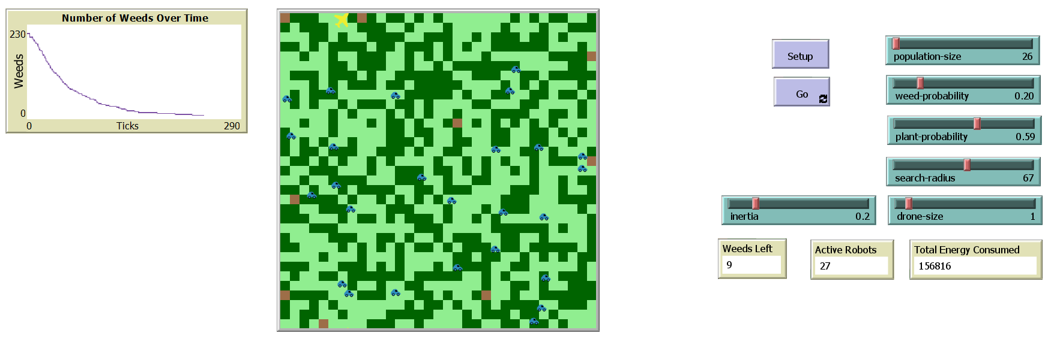

**Figure2: NetLogo Setup (static)**

**Behavior Definitions**

Each agent type has distinct behaviors that govern its interactions with the environment and other agents:

|  |  |
| --- | --- |
| **Agent Type** | **Description** |
| Ground Robots | These agents navigate the field, seeking out and managing weed patches. Their behavior is governed by both local (personal best) and global knowledge (global best), influenced by algorithms that optimize their path planning for effective weed control. |
| Drones | These aerial agents assist in identifying high-density weed areas and relaying this information to ground robots. They operate based on a broader view of the field but do not interact directly with weeds. |

**Integration of Control Algorithms**

The simulation incorporates elements of swarm intelligence and reinforcement learning to adapt agent behaviors based on environmental feedback and interaction outcomes:

|  |  |
| --- | --- |
| **Agent Type** | **Description** |
| Path Planning and Decision Making | Agents use a combination of reactive and planned behaviors to navigate the field. The decision-making process is influenced by the immediate environment (local best) and information from other agents (global best). |
| Learning Mechanisms | Agents adjust their strategies based on success rates in previous actions, improving their efficiency in weed detection and removal over time. |

**Simulation Execution Using Behavior Space**

NetLogo's Behavior Space tool is used to run multiple simulations under varied conditions to systematically explore the effects of different parameters on the system's effectiveness. This tool automates the process of changing parameters and recording results, facilitating extensive data collection without manual intervention.

|  |  |
| --- | --- |
| **Agent Type** | **Description** |
| Parameter Testing | Various configurations are tested, including different ratios of ground robots to drones, variations in weed density, and changes in the robots' sensing capabilities. |
| Metrics Collection | Key performance metrics such as total area cleared of weeds, energy consumption, and time to clear the field are automatically recorded. These metrics are crucial for assessing the effectiveness of the swarm robotics system in real-time and post-simulation analyses. |

**Data Analysis and Optimization**

Data collected from simulations are exported for analysis with Python using libraries like Pandas and Matplotlib for advanced statistical analysis and visualization. This analysis is vital for understanding agent behavior patterns, system efficiency, and identifying potential improvements.

|  |  |
| --- | --- |
| **Agent Type** | **Description** |
| Performance Evaluation: | The simulation data is analyzed to evaluate the performance of the system under various operational scenarios. Insights gained from this analysis inform iterative improvements to the agent algorithms and system parameters.  Iterative Refinement: Adjustments to the algorithms and agent behaviors are made based on performance data, enhancing the system's overall efficiency and effectiveness in subsequent simulation runs. |

This methodology ensures a robust and iterative approach to developing a scalable and effective agent-based model for agricultural enhancement using swarm robotics. The combination of detailed environmental setup, sophisticated agent behaviors, and rigorous testing and refinement cycles aims to maximize the potential of swarm robotics in improving agricultural productivity.

**RESULTS**

**Simulation Parameters**

Our simulation explored the effects of varying search radii, plant probabilities, weed probabilities, inertia values, population sizes, and drone sizes on the efficiency of an agent-based swarm robotics system in a simulated agricultural environment as shown in the table below. We conducted 729 runs to comprehensively understand the impact of these parameters on our system's performance.

|  |  |
| --- | --- |
| **Variables** | **Test Values** |
| search-radius | 40, 50, 60 |
| plant-probability | 0.4, 0.5, 0.6 |
| weed-probability | 0.1, 0.2, 0.3 |
| inertia | 0, 0.1, 0.2 |
| population-size | 15, 20, 25 |
| drone-size | 0, 1, 2 |

**Energy Consumption**

One of the key performance metrics was the total energy consumed (total-energy), reflecting the efficiency of the robots in terms of movement and weed detection tasks. Our analysis reveals trends where energy consumption increases with larger search radii, however, the number of steps required reduces. This suggests that while larger search radii may speed up the detection rates, however, they require the robots to expend more energy. Furthermore, we see reduced energy consumption and steps when the ground robots are fixed to 15 suggesting opportunities to identify optimal mix of ground robots and search radius.



**Weed Detection Efficacy**

We noted variations in weed detection rates correlating with different plant and weed probabilities with higher energy consumption. It can be interpreted as higher plant probabilities reduced the visibility of weeds, leading to increased search efforts. Further, higher weed probabilities required more steps increasing the energy consumption.



**The Influence of Inertia**

The parameter of inertia shows a nuanced effect on the swarm's behavior. Zero inertia indicates an entirely reactive behavior requiring higher energy consumption, while higher inertia values suggest that robots are using their momentum leading to fewer steps and energy consumption.

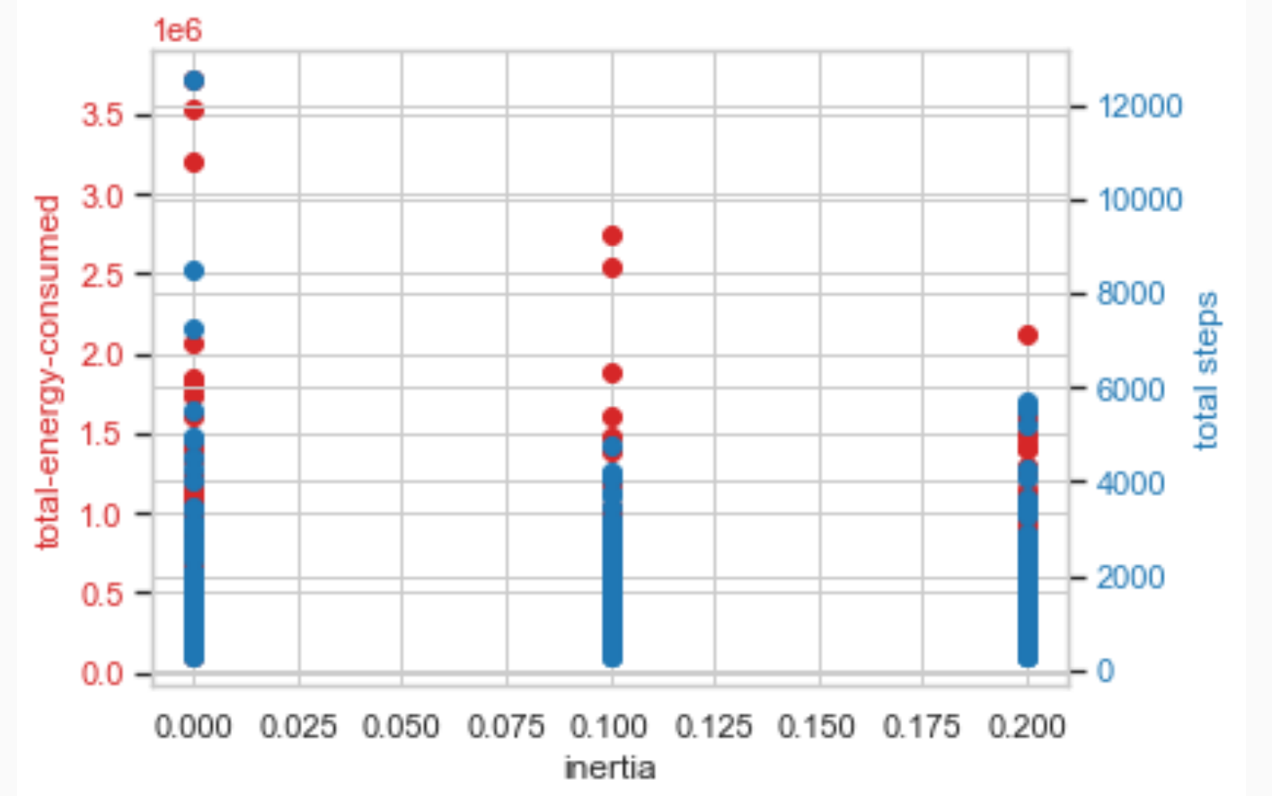

**Population Dynamics**

An increased population size of ground robots led to a more thorough coverage of the area, which is reflected in the proportional consistency of the energy consumption figures across different runs. However, an increased number of drones did not always correspond to increased efficiency (in terms of total steps or ticks), likely due to overlapping search areas leading to redundancy.



The analysis for optimal combination of search-radius and drone-size suggests having a higher search radius and higher number of drones. We may have to check simulations where for a given size of the farm the increase in search radius and drones will create in-efficiencies.

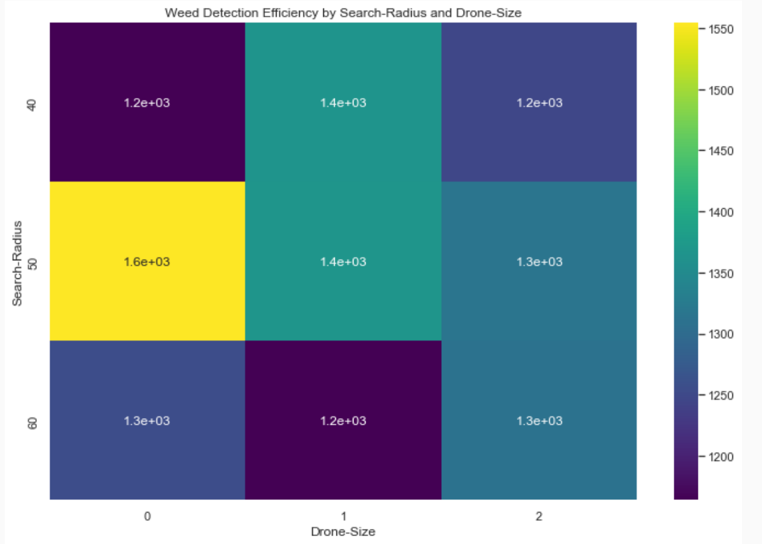

**Correlation Analysis**

The correlation analysis suggests that weed-probability, population-size of ground robots have a higher positive correlation with Total-energy-consumed. The population-size is negatively correlated to total steps suggesting that the number steps required to detect weeds decreases with increased population-size of the ground robots.

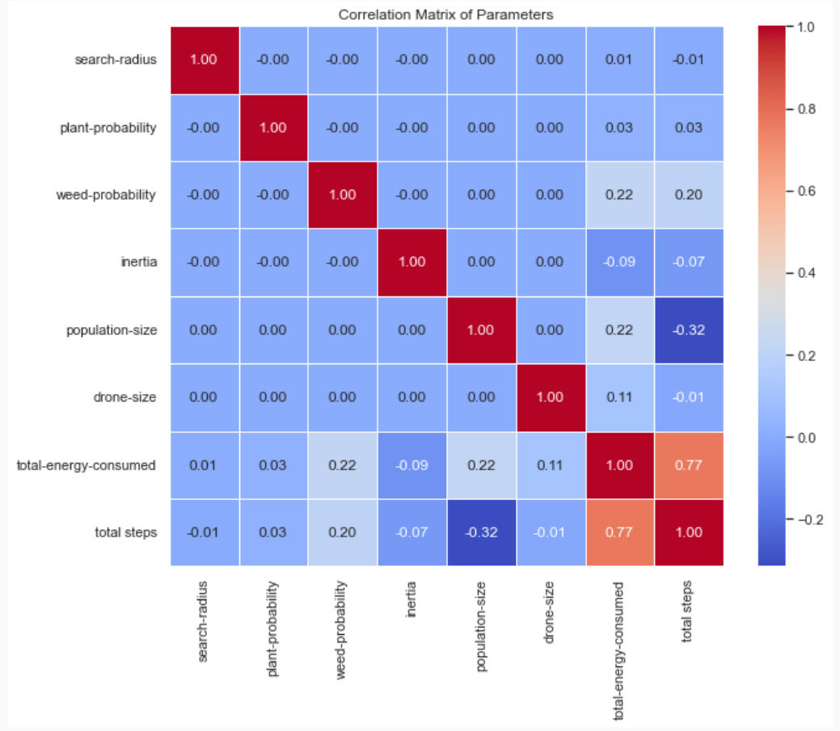

**Pair plot Analysis:**

The pair plot has scatterplots for all 6 input parameters and the 2 output parameters (energy consumed & time) - all plots are as per expectations. Moreover, we observe that total steps have a positive correlation with Total-energy-consumed, and the population-size is negatively correlated to total steps (time).

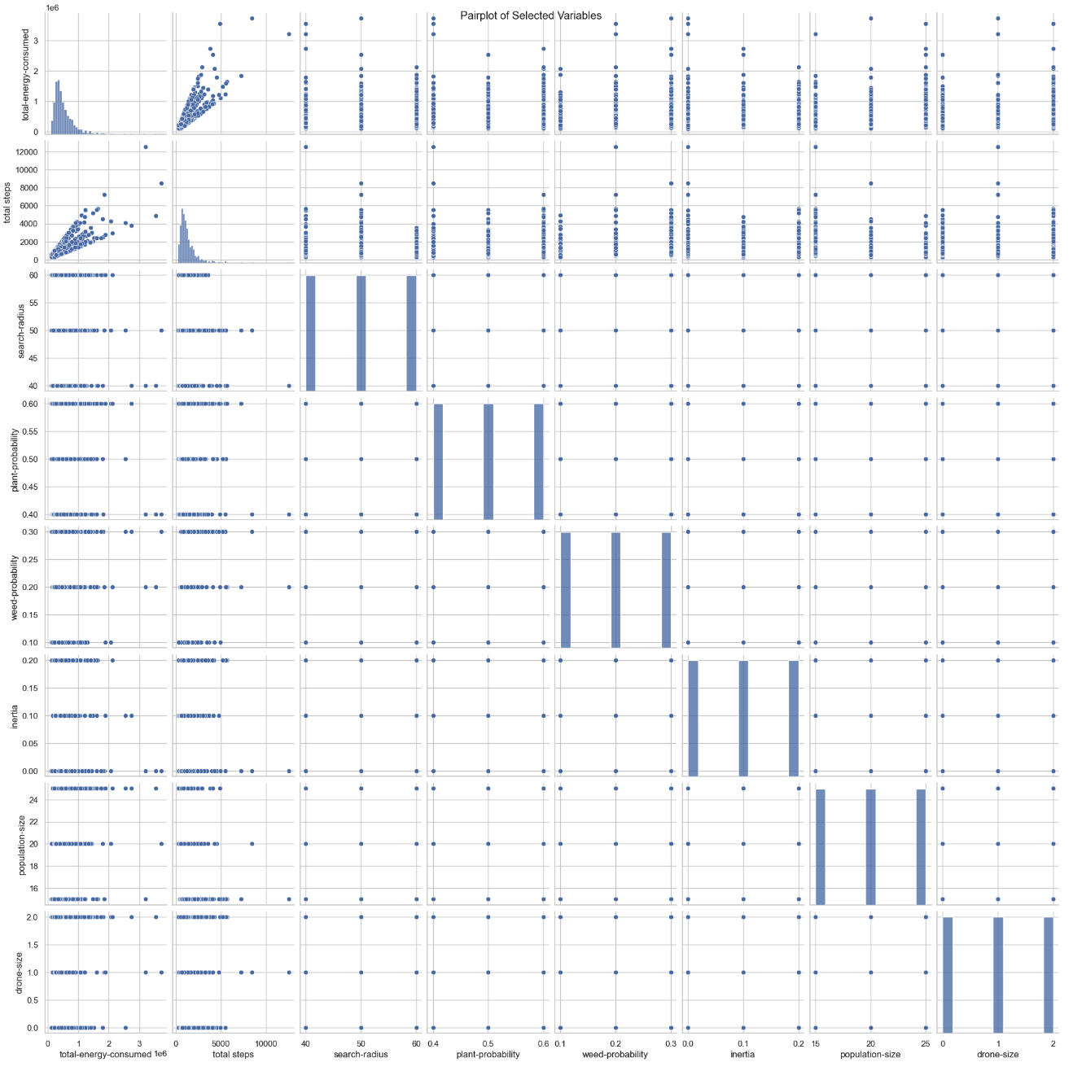

**Summary of Key Findings**

* Larger search radii and drone sizes are more energy intensive.
* Weed detection rates are affected by the density of plants and weeds in the environment with higher density requiring higher energy requirements.
* Inertia affects the movement patterns and response rates of the robots. Higher inertia in ground robots requires a smaller number of steps to identify weeds.
* Increased robot populations cover more area but may also lead to increased energy consumption without corresponding efficiency gains in weed detection.

The BehaviorSpace tool in NetLogo has enabled us to conduct extensive simulation runs, providing valuable insights into the trade-offs between search thoroughness, energy efficiency, and robot responsiveness. These findings will inform further adjustments to the algorithm for enhanced performance in real-world applications.

**NEXT STEPS**

**Implement Additional Goals:**

As we progress beyond the current scope of our simulation and the set targets, we may look at expanding our project goals provided below.

|  |  |  |
| --- | --- | --- |
| **Sr. No.** | **Additional Goals** | **Description** |
| 1 | Rescue Operations for Stuck Robots | To ensure the robustness of our system, we plan to implement algorithms that can identify and execute rescue operations for immobilized ground robots. By enabling robots to assist each other in overcoming obstacles and mechanical failures, we aim to enhance the resilience and autonomy of the swarm as a whole. |
| 2 | Integration of Aerial Vehicles for Complex Tasks | The versatility of drones offers untapped potential for intricate tasks. We envision integrating aerial vehicles capable of not just surveillance but also performing complex actions such as targeted spraying, pollination, or even the transport of smaller ground robots across difficult terrain. |
| 3 | Advanced Plant Health Monitoring | Leveraging machine learning tools like TensorFlow, we aim to train our agents to not only detect weeds but also identify disease in crops such as soybeans. This advancement would be a significant step toward holistic crop management, where early detection and treatment of disease are critical for yield optimization |

**Algorithmic Improvements**

PSO Algorithm Optimization: Central to our next phase is the improvement of the PSO algorithm. We recognize that an increase in search radius and drone quantity must have a proportional effect on the efficiency and optimization of the swarm. By refining the PSO parameters and introducing adaptive mechanisms, we will ensure that our robots not only work smarter but also conserve energy, thereby enhancing the sustainability of the operation.

**CONCLUSION**

The PSO algorithm was successfully used to achieve the set targets for navigation, coordination of ground robots and drones. Further, the PSO algorithm enabled optimized task execution across the farm landscape. Our robots have not just identified weeds but have also simulated their removal, offering a glimpse into the potential of fully automated weed management systems.

As we look to the future, we look to broaden the capabilities of our swarm, from rescuing immobilized robots to integrating more complex tasks into their repertoire, such as health monitoring of crops with advanced machine learning techniques. These steps forward will refine our approach to sustainable agriculture, making the most of each robot's potential and laying the groundwork for autonomous systems to flourish across diverse agricultural scenarios.

**REFERENCES**

* Albiero, D., Garcia, A., Umezu, C., & Paulo, R. (2022). Swarm robots in Mechanized Agricultural Operations: A review about challenges for research. Computers and Electronics in Agriculture. <https://www.sciencedirect.com/science/article/abs/pii/S0168169921006256>
* Akhloufi, M., & Blais, M. (2023). Reinforcement learning for swarm robotics: An overview of applications, algorithms and simulators. Cognitive Robotics. <https://www.sciencedirect.com/science/article/pii/S2667241323000241>
* Botteghi, N. & Kamilaris, A., Sinai, L. & Sirmacek, B. (2020). Multi-Agent Path Planning of Robotic Swarms in Agricultural Fields. Annals of Photogrammetry, Remote Sensing and Spatial Information Sciences. V-1-2020. 361-368. 10.5194/isprs-annals-V-1-2020-361-2020.
* Bunte, S. (2021). Introducing cooperativeness for agrobotics : An agent-based approach. <https://essay.utwente.nl/88141/1/Bunte_MA_BMS.pdf>
* Calderón-Arce C, Brenes-Torres JC, Solis-Ortega R. Swarm Robotics: Simulators, Platforms and Applications Review. Computation. 2022; 10(6):80. <https://doi.org/10.3390/computation10060080>
* Carbone, C., Garibaldi, O., & Kurt, Z. (2018). Swarm Robotics as a Solution to Crops Inspection for Precision Agriculture. KnE Engineering, 3(2), 552-562. https://doi.org/10.18502/keg.v3i1.1459
* Din, A., Ismail, M., Shah, B., Babar, M., Ali, F., & Baig, S. (2022). A deep reinforcement learning-based multi-agent area coverage control for Smart Agriculture. Computers and Electrical Engineering. <https://www.sciencedirect.com/science/article/abs/pii/S0045790622003445>
* Kiani F, Seyyedabbasi A, Nematzadeh S, Candan F, Çevik T, Anka FA, Randazzo G, Lanza S, Muzirafuti A. (2022). Adaptive Metaheuristic-Based Methods for Autonomous Robot Path Planning: Sustainable Agricultural Applications. Applied Sciences. <https://doi.org/10.3390/app12030943>
* Kuhlmann, S. (2021). Adaptive swarm robotics could revolutionize smart agriculture. Texas A&M Today. <https://today.tamu.edu/2021/11/15/adaptive-swarm-robotics-could-revolutionize-smart-agriculture/>
* Olaronke, I., Rhoda, I., Gambo, I., Oluwaseun, O., & Janet, O. (2020). A Systematic Review of Swarm Robots. Current Journal of Applied Science and Technology, 39(15), 79–97. <https://doi.org/10.9734/cjast/2020/v39i1530719>
* Rosenberger, C., Arguenon, V., & Bergues-Lagarde, A. (2006). Multi-agent based prototyping of Agriculture Robots. International Symposium on Collaborative Technologies and Systems (CTS’06). <https://www.academia.edu/55634151/Multi_Agent_Based_Prototyping_of_Agriculture_Robots>
* Saga - Swarm Robotics for agricultural applications. (2019. The European Coordination Hub for Open Robotics Development. <https://echord.eu/saga.html>
* Tian, H., Wang, T., Liu, Y., Quiao, X., & Li, Y. (2019, September 27). Computer Vision Technology in Agricultural Automation -A Review. Information Processing in Agriculture. <https://www.sciencedirect.com/science/article/pii/S2214317319301751#b0175>
* Altaheri, H., Alsulaiman, M., Muhammad, G., Amin, S., Bencherif, M., & Mekhtiche, M. (2019, September 18). Date fruit dataset for intelligent harvesting. Data in Brief. <https://www.sciencedirect.com/science/article/pii/S2352340919308698?via%3Dihub>
* Haug, S. cwfid/dataset: A Crop/Weed Field Image Dataset. GitHub. <https://github.com/cwfid/dataset>
* Menber, J. josemenber/image-based-crop-anomaly-detection: A Convolutional Neural Network approach for image-based anomaly detection in smart agriculture. GitHub. <https://github.com/josemenber/image-based-crop-anomaly-detection>
* Olsen, A. Alexolsen/deepweeds: A multiclass weed species image dataset for deep learning. GitHub. <https://github.com/AlexOlsen/DeepWeeds>
* Plant_disease_resnet50. Kaggle. <https://www.kaggle.com/code/aryanml007/plant-disease-resnet50/notebook>
* Rice Classification  ~99.2% Accuracy. Kaggle. <https://www.kaggle.com/code/mushfirat/rice-classification-99-2-accuracy/comments>
* Sa, I. (2019). DeepFruits_dataset. Google Drive. <https://drive.google.com/drive/folders/1CmsZb1caggLRN7ANfika8WuPiywo4mBb>
* Weed detection in soybean crops. Kaggle. (2018, September 12). <https://www.kaggle.com/datasets/fpeccia/weed-detection-in-soybean-crops>
* Petruk, I. Agricultural Robotics drivers and trends. Infopulse. https://www.infopulse.com/blog/agricultural-robotics-drivers-trends#:~:text=The%20agricultural%20robotics%20sector%20is,annual%20growth%20rate%20of%2024.3%25.
* AI tools such as ChatGPT, Gemini, Co-pilot

**APPENDIX A – PROJECT TIMELINES**

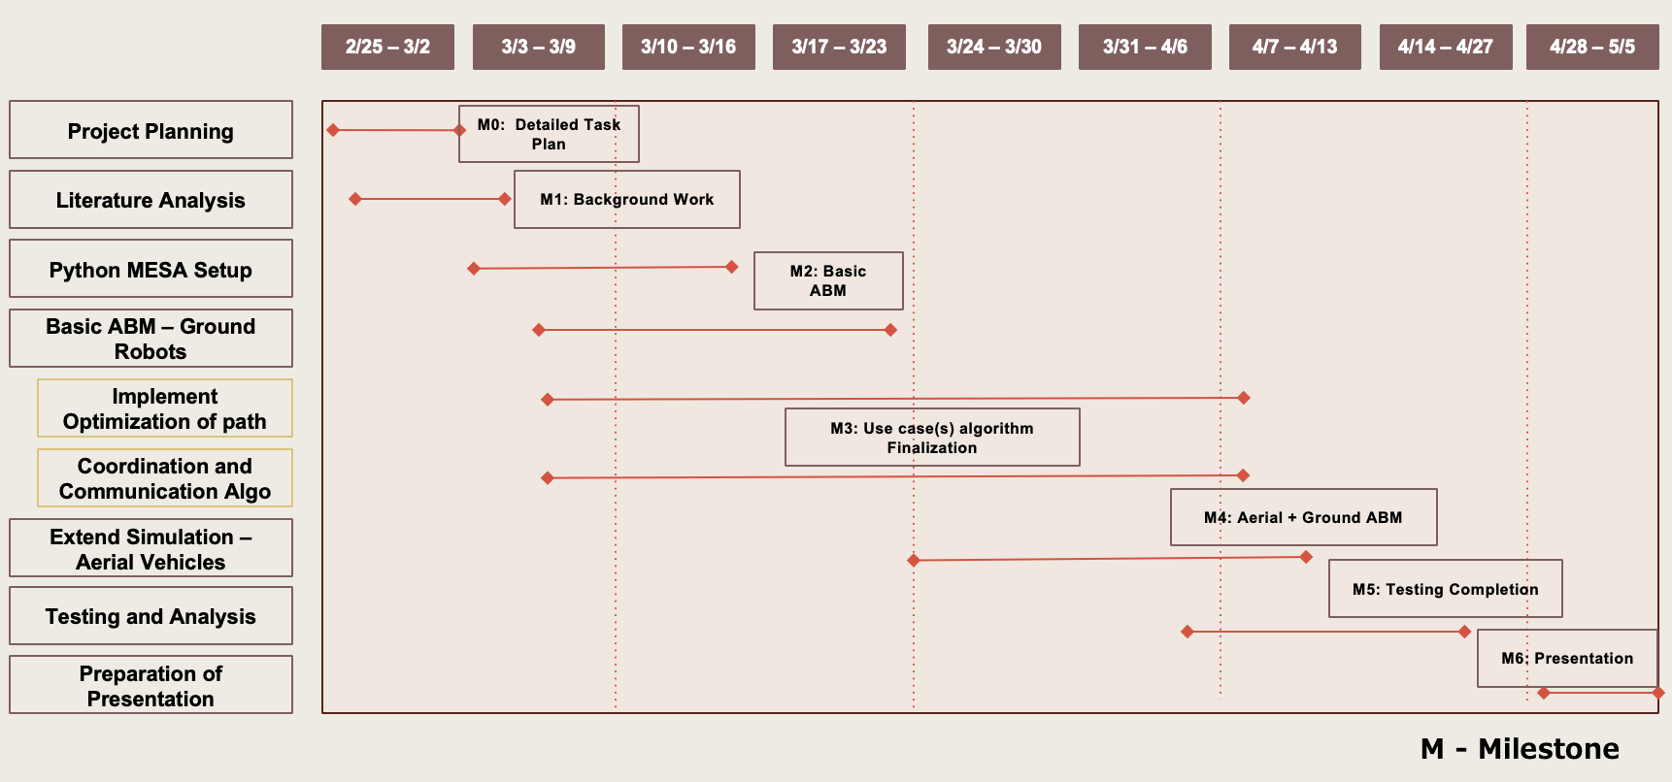

**APPENDIX B – TEAM RESPONSIBILITIES**

|  |  |  |  |
| --- | --- | --- | --- |
| **High-Level Tasks** | **Bethlehem** | **Bethun** | **Tousif** |
| **Project Planning** | Responsible | Responsible | Responsible |
| **Literature Analysis** |  |  |  |
| Algorithm Identification | Responsible | Support | Responsible |
| Data Set finalization (Target and Stretch) |  | Responsible | Support |
| Determine Testing Parameters | Responsible |  | Responsible |
| **Netlogo Setup** |  |  |  |
| Netlogo Environment Setup | Support | Responsible | Responsible |
| **Basic ABM – Ground Robots** |  |  |  |
| Definition of Agents | Support | Responsible | Responsible |
| Visualization plan for agents | Responsible | Support | Support |
| Coordination and Communication Algorithm | Responsible | Responsible | Support |
| Implement Optimization of Path Algorithm | Support | Responsible | Responsible |
| **Extend Simulation to Aerial Vehicles** |  |  |  |
| Coordination and Communication Mech | Responsible | Responsible | Support |
| Implement Optimization of path | Support | Responsible | Responsible |
| **Testing and Analysis** | Responsible | Responsible | Responsible |
| **Preparation of Presentation** | Responsible | Responsible | Responsible |